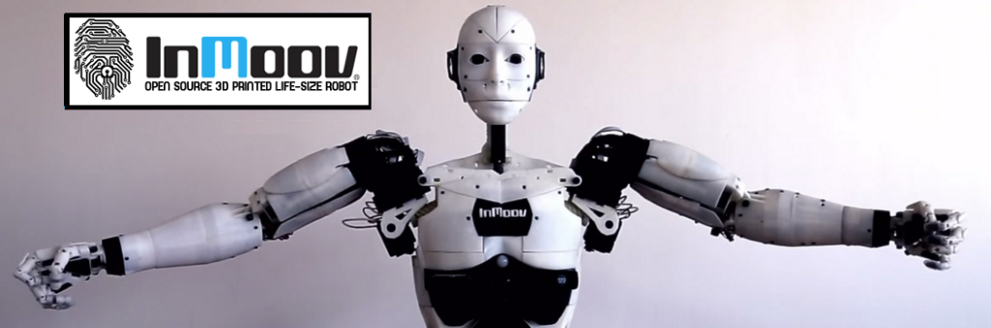

**Presentation & Subject Analysis**

**Identification:**

|  |  |
| --- | --- |
| Project Title | Robot Cognitif |
| Project Number | 65 |
| Team Referent | MARTIN Jérémy |
| Other members in team | EKHTERAEI Aria, GUILLAUME Thomas, MEZOUAR Chloé |
| Team Mentor | Jean-Philippe LELIEVRE |
| Project Partner | DaVinciBot |

**Work done since the last PRM review:**

-We changed the model and the algorithm in charge of creating the dataset. This new model uses the Dlib and face recognition library which allows to have only one picture for each person. This new model is also much more efficient.

-We searched for a database able to store pictures. It is possible with MySQL with the BLOB type.

-We had a presentation to do before the holidays about the organization of the team on the project.

**Difficulties encountered:**

-The installation of the Dlib library is very complicated on windows so we did it on Linux environment.

-We did not work a lot on the project since the last review because of the examination week and the holidays.